**NAME: AVANI KASAT**

**19BCE1058**

**TASK 1**

**---------------------------------------------------------------------------------------------------------------------------------------------------**

**S-1. Create a new folder with a app name and open VS code in the current folder  
S-2. Once in the current folder on VS code open a new terminal from the top toolbar  
S-3. In the current termical execute - npm install react-native-cli**

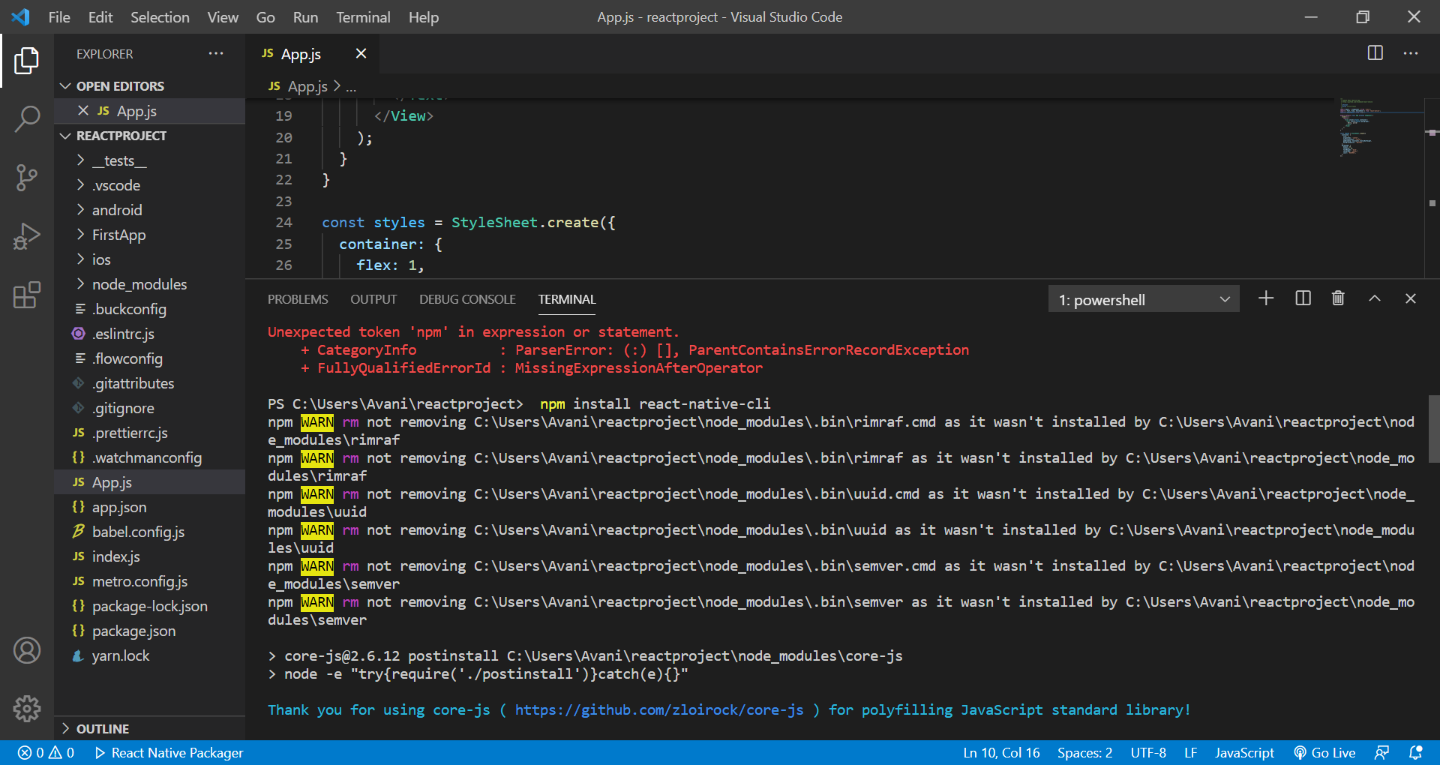

**S-4. In the termical copy the following command - npx react-native init FirstApp**

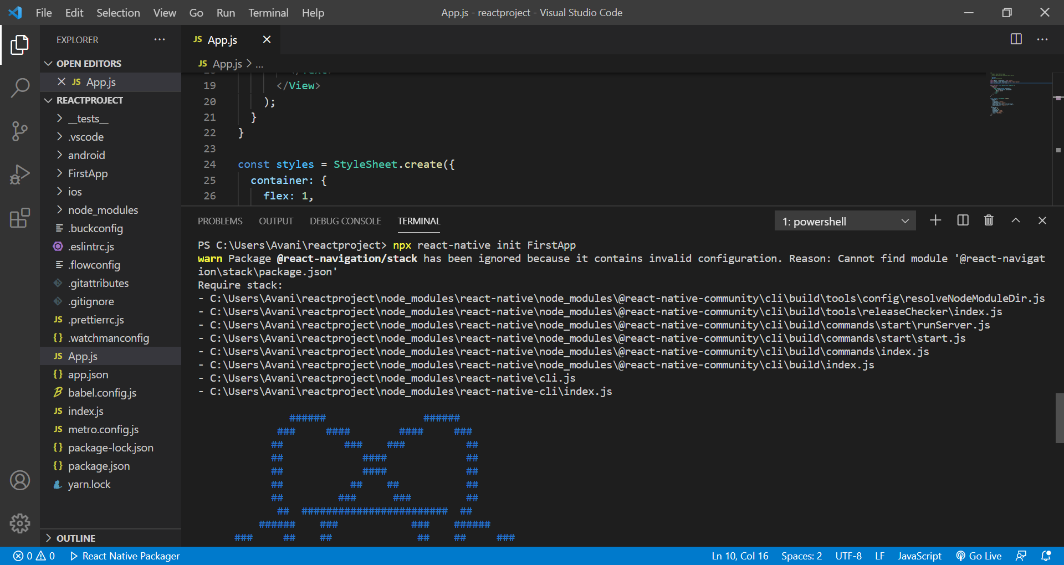

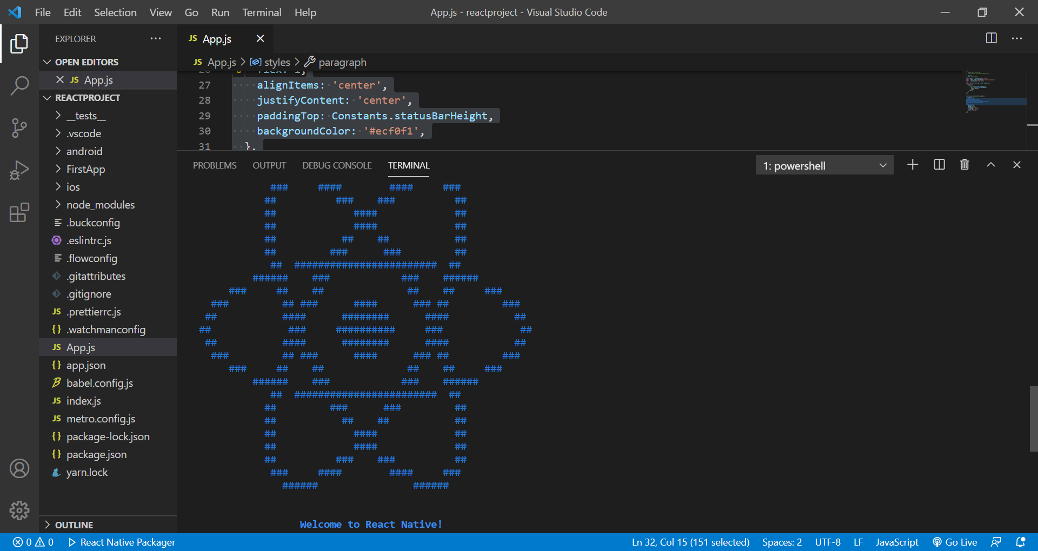

**S-5. FirstApp is the name of your newly created app ,**

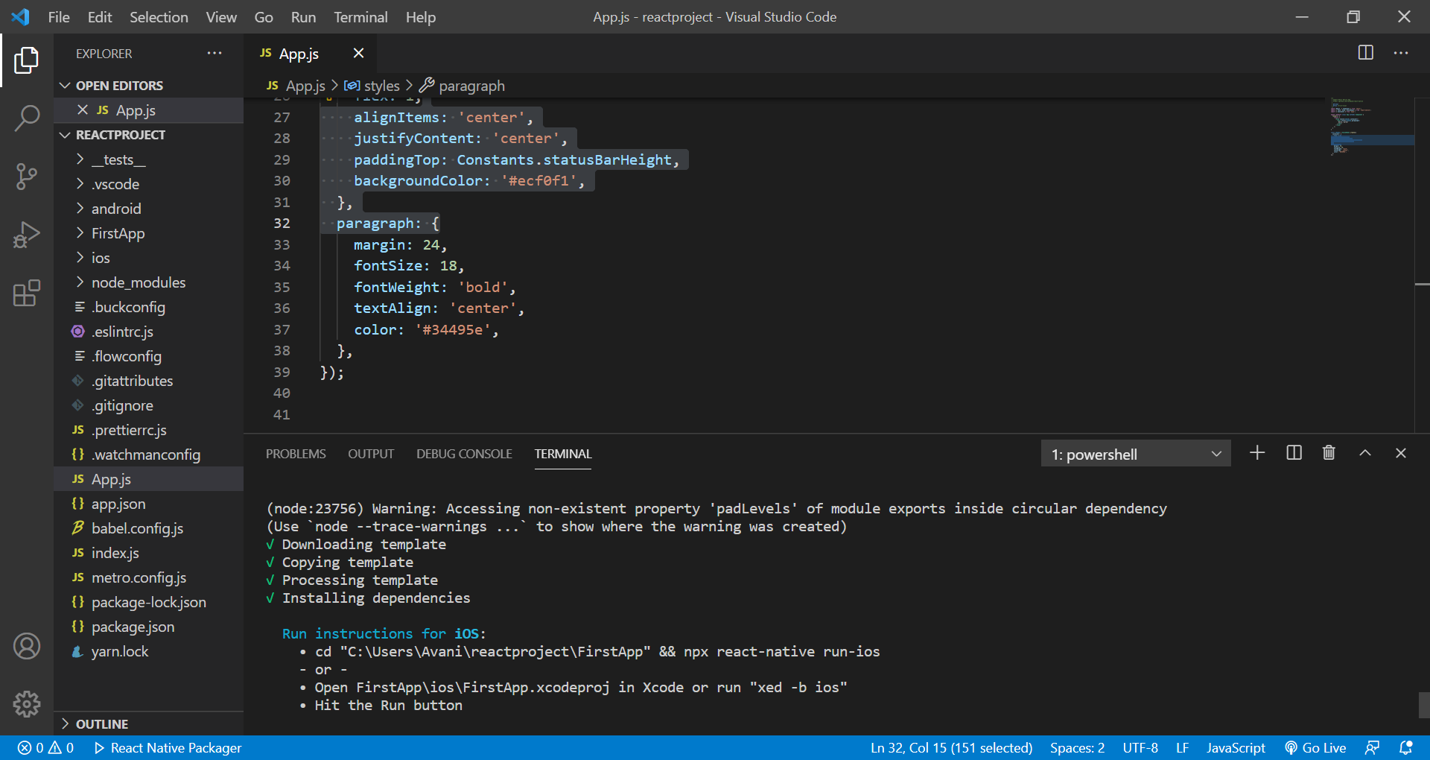

**Running your app**

**S-6: Once your setup has been completed , move to your app directory and execute the folloowing command based on your machine type.  
Windows - npx react-native run-android**

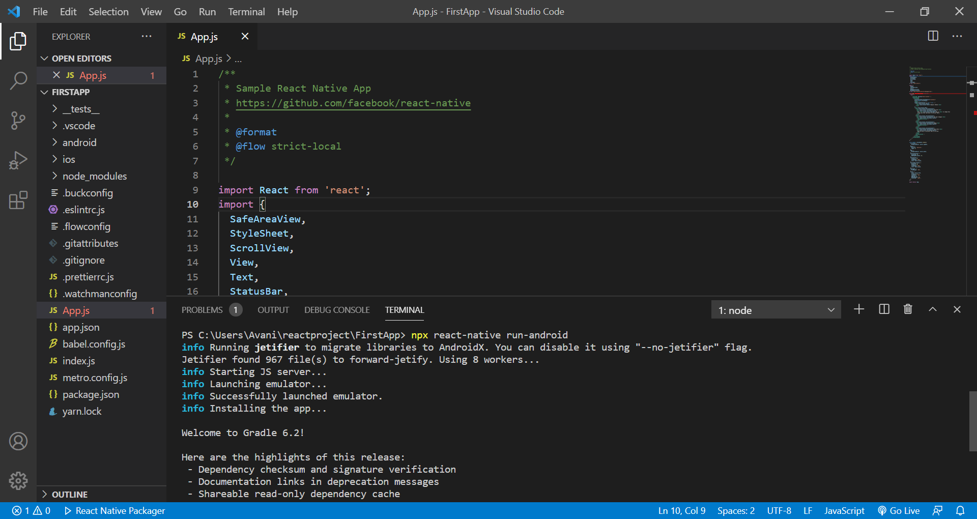

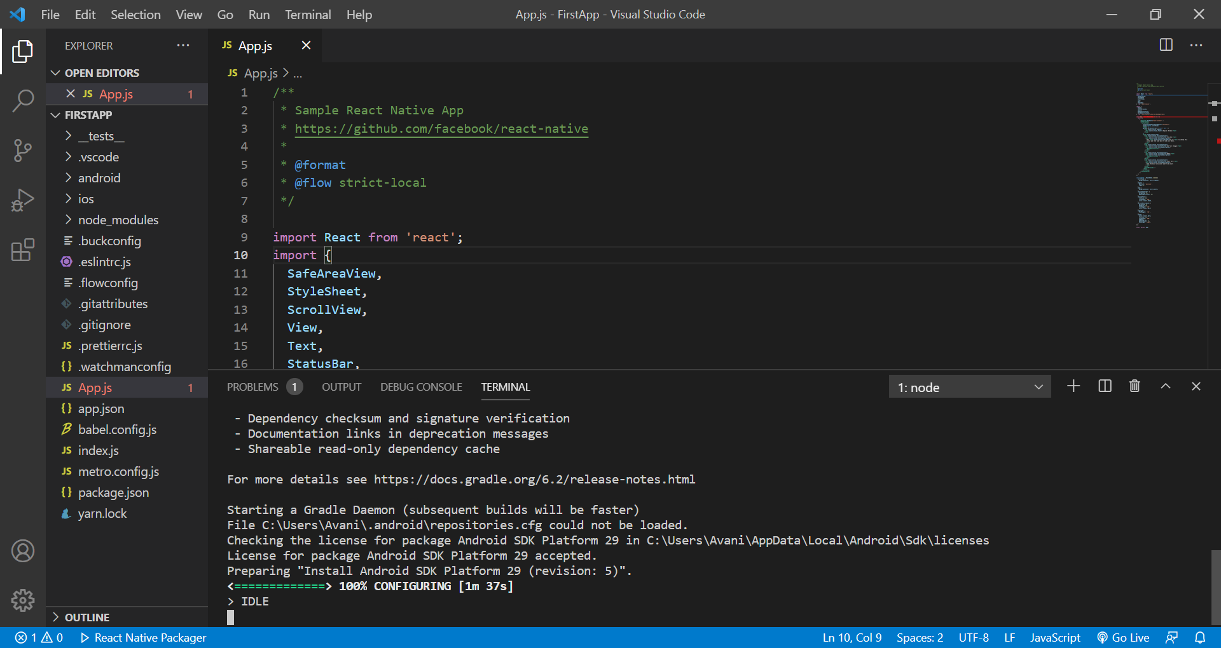

**S-7. Press the R key twice or select Reload from the Developer Menu (Ctrl + M) to see your changes!**

